A special edition for a special occasion: the new EDA magazine is out!

Brussels - 25 June, 2019

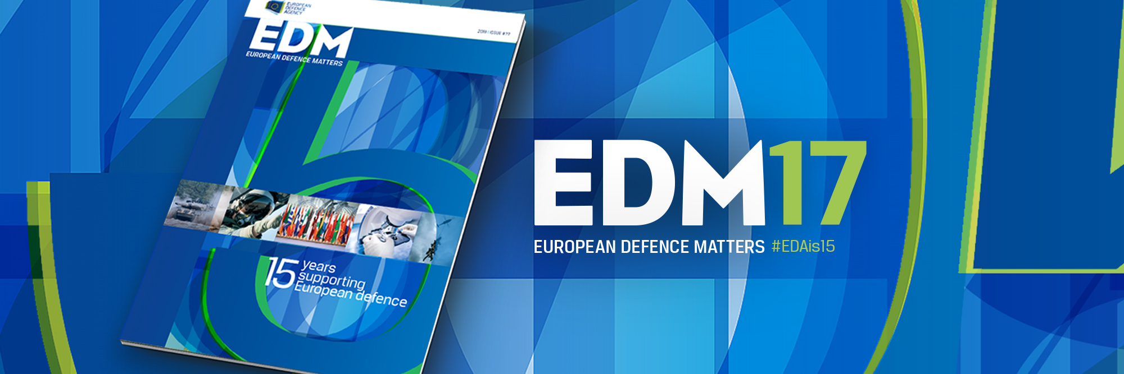

**The latest *European Defence Matters* magazine (N°17) is now available. This special edition is entirely focused on the European Defence Agency’s 15th Anniversary which is being celebrated this summer. Together with previous and current stakeholders, decision-makers and partners, we look back at how the Agency has evolved over the past 15 years, what it has achieved so far and what its future prospects are.**[**This special 15th Anniversary edition is already available in PDF**](https://www.eda.europa.eu/docs/default-source/eda-magazine/edm17singleweb)**and will soon also be accessible via online version.**

After a foreword by Federica Mogherini, the Head of the Agency, the magazine reviews the events and developments in 2002/2003 (European Convention, Thessaloniki European Council, etc.) which led to the creation of the Agency in 2004. Javier Solana, the first EU High Representative for the Common and Security Policy (1999-2009) and first Head of EDA (2004-2009), also shares his recollections and analyses in an interesting and exclusive article for *European Defence Matters*.

We also sat down with those who, as Chief Executives, have steered the Agency through 15 exciting yet challenging years: Nick Witney (2004-2007), Claude-France Arnould (2011-2015) and Jorge Domecq who is currently (since 2015) in charge. Alexander Weis, who served as Chief Executive from 2007-2011, could unfortunately not attend this joint interview.

Member States’ views on EDA’s role and achievements in EU Defence are represented in this magazine by Finnish Defence Minister Antii Kaikkonen who explains in his contribution why the Agency is *“the right intergovernmental platform for joint capability prioritisation, planning and development”*.

In a series of six articles, we then describe and assess what can probably be considered as EDA’s main achievements over the past 15 years during which the Agency has established itself as: - the main architect of EU defence capability priorities; - the manager of European defence research; - the European hub for multinational capability development; - the military voice and interface for EU policies; - Europe’s training pitch for enhanced interoperability; - the guardian of coherence among the newly set-up EU defence cooperation tools.

In the ‘Industry Talk’ section, MBDA’s new CEO Eric Béranger shares his views on how European defence cooperation in Europe (and EDA’s role in it) have evolved over the past 15 years and what the industrial prospects and challenges are for the future. He also touches upon the implementation of the recent EU defence initiatives (CARD, PESCO, EDF).

The NATO view on European defence, EDA and EU/NATO cooperation is provided for this magazine by former NATO Assistant Secretary General for Defence Policy & Planning, Heinrich Brauss, who is now a Senior Associate Fellow at the German Council on Foreign Relations (DGAP).

Thoughts and reflections by representatives of some of EDA’s main partner organisations as well as a very interesting and inspiring outlook analysis (*‘Quo Vadis EDA?’*) by Dick Zandee, Head of the Security Unit of the research department of the Clingendael Institute in The Hague) round off this very special *European Defence Matters* magazine.

Have a look immediately – and enjoy!